/*Linear search
Name: Shubham Sarang
ROll NO: 1345
Unit 2 Searching
Program: Linear search
*/
#include<iostream>
using namespace std;
int main()
{
int i, n, arr[20];
int target, flag=0;

cout<<"**Linear Search**"<<endl<<endl;

cout<<"Enter size of array: ";
cin>>n;

cout<<endl;

cout<<"Enter number of elements: ";

for(i=0; i<n; i++)
{
cin>>arr[i];
}

cout<<endl;

cout<<"Enter element to be searched: ";
cin>>target;

//Logic
for(i=0; i<n; i++)
{
if(arr[i] == target)
{
flag = 1;
break;
}
}
if(flag == 1)
{
cout<<"Element found at index "<< i;
}
else
{
cout<<"Element not found";
}

}//end main
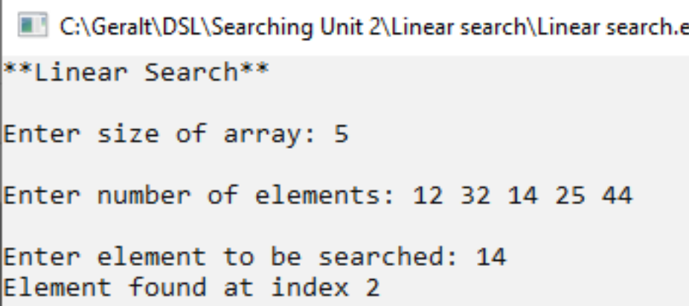
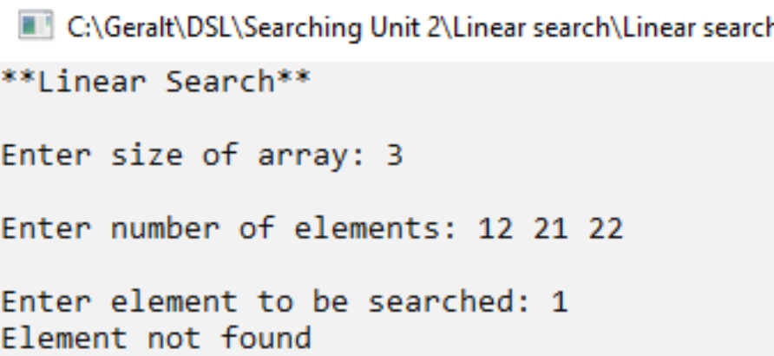
/*
Name: Shubham sarang
Roll no: 1345
Unit 2: Binary search
*/
#include<iostream>
using namespace std;
int main()
{
int n, i, flag=0, arr[20];
int first, last, mid, target;
cout<<"***Binary Search***"<<endl;
cout<<"Enter size of array: ";
cin>>n;

cout<<endl;

cout<<"Enter elements of an array: ";
for(i=0;i<n;i++)
{
cin>>arr[i];
}

cout<<endl;

cout<<"Enter target: ";
cin>>target;

//logic
first= 0;
last= n-1;

while(first <= last)
{
mid = (first + last)/2;
if(target<arr[mid])
{
last = mid - 1;
}
else if(target > arr[mid])
{
first = mid + 1;
}
else
{
flag = 1;
break;
}
}

cout<<endl;

if(flag==0)
{
cout<<"Target not found";
}
else
{
cout<<"Target found at index "<<mid;
}

}//end main
